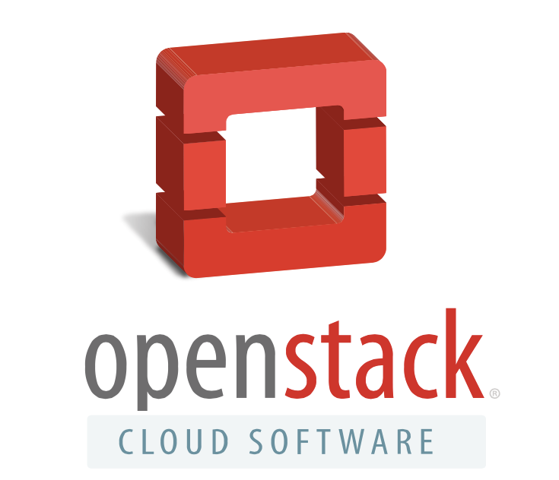

<Date>

Dear XXXX
OpenStack Days are regional events that bring together hundreds of IT executives, cloud operators and technology providers to discuss cloud computing and to learn about OpenStack. These annual events are supported by the OpenStack Foundation and are organized by a community of local OpenStack user groups and supporting companies.
The OpenStack Day <enter your location> is a nonprofit community event, organized by ecosystem players and supported by the OpenStack Foundation. Our event this year features the following programs:
- <add your agenda here>
We are looking for sponsors to support our event in <enter the location> on <date> located at the <enter the event location>. We invite you to visit our webpage for additional event and sponsorship details at <enter your website url>.
If you are interested in learning how your company can sponsor the OpenStack Day <location> event, please contact <name and contact information>.
OpenStack® is open source software for building clouds and is backed by the independent OpenStack Foundation and a global community of more than 34,000 individual members and 550 supporting organizations across 177 countries. OpenStack-powered clouds enable businesses to rapidly develop and deploy new applications while reducing technology lock-in.

